

AUTOMATED FOOD IMAGE CLASSIFICATION USING
DEEP LEARNING

A PROJECT REPORT

Submitted by

AARTHI B [927621BAD002]

HARSHINI M [927621BAD016]

VINOHARSITHA A S [927621BAD060]

VISHNU PRIYA C [927621BAD062]

in partial fulfillment for the award of the degree

of

BACHELOR OF TECHNOLOGY

IN

ARTIFICIAL INTELLIGENCE AND DATA SCIENCE
M.KUMARASAMY COLLEGE OF ENGINEERING, KARUR ANNA UNIVERSITY:: CHENNAI 600 025
NOV 2023

ANNA UNIVERSITY: CHENNAI 600 025

BONAFIDE CERTIFICATE

Certified that this project report “AUTOMATED FOOD IMAGE CLASSIFICATION USING DEEP LEARNING” is the bonafide work of “AARTHI B [ 927621BAD002], HARSHINI M [927621BAD016], VINOHARSITHA A S [927621BAD060], VISHNUPRIYA C [927621BAD062]” who carried out the project work under my supervision.

SIGNATURE
Dr.R.RajaGuru,M.tech.,Ph.D
ASSOCIATE PROFESSOR AND HEAD
Department of Artificial Intelligence
M.Kumarasamy College Of Engineering,
Karur-639113
SIGNATURE
Mr.R.StalinBabu.M.E
SUPERVISOR
Assistant Professor,
Department of Artificial Intelligence
M.Kumarasamy College Of Engineering,
Karur-639113

TABLE OF CONTENTS

CHAPTER NO | TITLE | PAGE NO
 | ABSTRACT | 5
 | LIST OF FIGURES | 6
 | LIST OF TABLES | 6
 | ACRONYMS/LIST OF ABBREVIATIONS | 7
1 | INTRODUCTION | 8
 | 1.1 BACKGROUND | 9
 | 1.2 PROBLEM STATEMENT | 11
 | 1.3 OBJECTIVES | 12
2 | LITERATURE REVIEW | 13
3 | FEASIBILITY STUDY | 18
 | 3.1 DATA PROCESSING AND | 19
 | TRAINING
 | 3.2 TESTING ACCURACY MODULE | 19
 | 3.3 CREATING WEB PAGE | 19
 | 3.4 ABOUT PAGE MODULE | 20

4 | PROJECT METHODOLOGY | 21
 | 4.1 DESCRIPTION OF WORKING | 22
 | FLOW OF PROPOSED
 | SYSTEM.
 | 4.2 DATA COLLECTION | 22
 | 4.3 DATA PRE-PROCESSING | 23
 | 4.4 FEATURE SELECTION AND | 23
 | ENGINEERING
 | 4.5 MODEL DEVELOPMENT | 24
 | 4.6 RESULT AND DISCUSSIONS | 25
5 | RESULTS AND DISCUSSIONS | 26
6 | CONCLUSION | 32
7 | REFERENCES | 34

ABSTRACT

The proposed system employs a Convolutional Neural Network (CNN) architecture, specifically tailored for food recognition tasks. The CNN is trained on a diverse dataset comprising thousands of annotated food images, encompassing a wide range of cuisines, dishes, and presentation styles. Transfer learning techniques are utilized to capitalize on pre-trained models, enhancing the network's ability to extract high-level features from the food images. Furthermore, a comprehensive evaluation of the model's performance is conducted using various metrics, including precision, recall, and F1-score. Comparative experiments with state-of-the-art food recognition models validate the effectiveness and superiority of the proposed approach. The results demonstrate exceptional accuracy in food classification across a diverse set of culinary items. The system exhibits robustness in handling complex and cluttered backgrounds, providing reliable results even in challenging scenario. Moreover, the model's efficiency allows for real-time processing, making it suitable for deployment in mobile applications and smart kitchen appliances. In conclusion, this research contributes a highly effective automated food image classification system, leveraging deep learning techniques.

LIST OF FIGURES

Figure No | Figure Name | Page No
1 | Description of the working flow of proposal system | 18
2 | Diabetes Prediction | 19
3 | Heart Disease Prediction | 20
4 | Parkinson’s Disease Prediction | 21

CHAPTER-1

INTRODUCTION

  - BACKGROUND:
Traditional approaches In the field of healthcare there is a growing demand for more precise and efficient diet prediction often rely on manual analysis and can be limited by human biases and resource constraints. Deep learning (DL),powered by datasets and advanced algorithms , has emerged as a promising solution to address these challenges.

1.1.1 COLLECT AND ANONOTATE DATA:
Clearly define what you want to achieve with the food image classification and specifies the category of foods and determine the number of classes.
1.1.2 PREPROCESS THE IMAGES:
Resize the images to a uniform size and this can help speed up training and reduce memory requirements and normalize the pixel values at a consistient range and argument the dataset with techniques like rotation, flipping , zooming and changing brightness/contrast. This helps the model generalize better to different variations of the same food item
1.1.3 SPLIT THE DATASET:
Divide the dataset into three subsets like training , validation, and testing. A common split is 70-15-15, where 70% of the data is used for training, 15% for validation (used for hyperparameter tuning) and 15% for testing(used to evaluate the final model).
1.1.4 CHOOSE A CONVOLUTION NEURAL NETWORK ARCHITECTURE:
CNN are commonly used for image classification tasks. You can start with well-known architectures like VGG, ResNet , inception, and fine – tune them for specific task.
1.1.5 TRAIN THE MODEL:
Use the training set to train the initial model. During training , the model learns to recognize patterns in the images and assign appropriate class labels.
1.1.6 VALIDATE AND FINE – TUNE:
Use the validation set to monitor the models performance. Adjust hyperparameters and
Consider making changes to the architecture if necessary .Be cautions not to overfit to the validation set.
1.1.7 EVALUATE ON THE TEST SET:
Once you have a satisfactory ,consider collecting more data , adjusting data augmentation techniques like transfer learning
1.1.8 DEPLOYMENT AND MONITORING :
Once you have a satisfactory model, you can deploy it your desired environment.Monitor its performance over time and update it as needed and remember that bulding an effective food image classifier may require multiple iterations of these steps as well as careful consideration of the specific may require multiple iterations of these steps as well as careful considerations of the specific challenges posed by your dataset .Additionally always be aware of ethical considerations related data collection and usage
1.1.9 COST SAVINGS :
The accurate prediction of diseases can result in substantial cost savings. Preventing diseases or diagnosing them at an early stage can alleviate the financial burden on both patients and healthcare systems by reducing the need for expensive, late-stage treatments.
1.1.10 IMPROVE PATIENT CARE :
The application of ML in disease prediction enhances the overall quality of patient care. Healthcare providers can make informed decisions based on data-driven insights, leading to better patient experiences and outcomes.
1.1.11 RESEARCH OPPURTUNITIES:
The use of ML generates extensive medical data, which can serve as a valuable resource for medical research. Researchers can gain new insights into disease mechanisms, potential treatments, and epidemiological trends, further advancing the field.
1.1.12 CHALLENGES AND ETHICAL CONSIDERATIONS:
While the potential benefits are substantial, the deployment of ML in disease prediction also presents challenges. Ethical concerns related to data privacy, bias, and model interpretability must be carefully addressed to ensure responsible and equitable use of these technologies

.

1.2 PROBLEM STATEMENT:

The increasing prevalence of various diseases, including heart disease, diabetes, and Parkinson's disease, has brought about significant healthcare challenges on a global scale. As these conditions continue to affect individuals worldwide, it becomes increasingly evident that early detection and prediction are critical components for effective preventive measures and optimized treatment planning.The primary objective of this project is to harness the power of machine learning to address these healthcare challenges. It seeks to develop predictive models capable of assessing an individual's likelihood of developing one or more of these diseases based on a diverse set of health-related features. This approach offers a holistic and data-driven solution for healthcare practitioners and individuals, allowing for a comprehensive health assessment tool that can revolutionize healthcare management.One of the key challenges this project faces is the collection and preprocessing of diverse medical data. Healthcare data comes in various formats and from numerous sources, including electronic health records, wearable devices, and medical imaging. This data must be aggregated, cleaned, and harmonized to create a consistent and reliable dataset for analysis. Moreover, ensuring data privacy and compliance with regulations, such as HIPAA, is paramount to protect patient information.

1.3 OBJECTIVES:

Revolutionize healthcare by harnessing the power of data-driven insights. This transformative approach aims to enhance the quality of patient care by developing accurate predictive models capable of identifying disease risk factors and patterns at an early stage. These models enable proactive interventions and the creation of personalized treatment strategies, ultimately leading to improved patient outcomes. By identifying individuals at risk of specific diseases, healthcare providers can implement preventive measures and interventions, reducing the The objective of employing machine learning for multiple disease prediction is to burden of illness and healthcare cost .In addition to improving patient care, the application of machine learning in disease prediction also plays a crucial role in optimizing resource allocation within the healthcare system. By identifying high-risk individuals and allocating resources accordingly, healthcare facilities can operate more efficiently, ensuring that those who need care the most receive it promptly. This approach not only enhances the overall healthcare experience but also contributes to cost reduction, making healthcare more accessible and affordable.Moreover, the generation of vast datasets and continuous research in the field of machine learning for disease prediction further advances our understanding of disease mechanisms and potential therapeutic approaches. This knowledge is invaluable for both medical researchers and healthcare practitioners, as it can pave the way for innovative treatments and interventions. Machine learning techniques can uncover hidden insights within the data, leading to breakthroughs in disease understanding and more effective treatment strategies.

CHAPTER 2
LITERATURE REVIEW

[1] Indian Food Image Classification with Transfer Learning

Image classification has become easier with deep learning and availability of large datasets and computational resources. The Convolutional neural network is the most popular and widely used image classification technique in the recent days. In this paper image classification is performed on Indian food dataset using different transfer learning techniques. The food plays important role in human's life as it provides us different nutrients and hence it is necessary for every individual to keep a watch on their eating habits. Therefore, food classification is a quintessential thing for a healthier life style. Unlike the traditional methods of building a model from the scratch, pre trained models are used in this project which saves the computation time and cost and also has given better results. The Indian food dataset of 20 classes with 500 images in each class is used for training and validating. The models used are
IncceptionV3, VGG16, VGG19 and ResNet. After experimentation it was found that Google InceptionV3 outperformed other models with an accuracy of 87.9% and loss rate of 0.5893.

[2] Machine learning techniques for analysis of hyperspectral images to determine quality of food products

Non-destructive testing techniques have gained importance in monitoring food quality over the years. Hyperspectral imaging is one of the important non-destructive quality testing techniques which provides both spatial and spectral information. Advancement in machine learning techniques for rapid analysis with higher classification accuracy have improved the potential of using this technique for food applications. This paper provides an overview of the application of different machine learning techniques in analysis of hyperspectral images for determination of food quality. It covers the principle underlying hyperspectral imaging, the advantages, and the limitations of each machine learning technique. The machine learning techniques exhibited rapid analysis of hyperspectral images of food products with high accuracy thereby enabling robust classification or regression models. The selection of effective wavelengths from the hyperspectral data is of paramount importance since it greatly reduces the computational load and time which enhances the scope for real time applications. Due to the feature learning nature of deep learning, it is one of the most promising and powerful techniques for real time applications. However, the field of deep learning is relatively new and need further research for its full utilization.

[3] Food Adulteration Detection Using Artificial Intelligence

Food Adulteration is a deceptive act of misleading food buyers for economic gain. It has been a major concern due to its risk to public health, reduction of food quality or nutritional value. It is a food fraud that has incensed the food industry and has attracted the attention of the community since the last century. To ensure consumer protection against fraudulent activities, authentication of food and the detection of adulterants in various food items should be taken into consideration. Artificial Intelligence has been proved to be an advanced technology in food science and engineering. In this paper, we intend to proclaim the role of artificial intelligence in food adulteration detection in a systematic way. The potential for machine learning and deep learning in food quality has been analyzed through its applications. Various data sources that are available online to detect food quality have been discussed in this review. The different techniques used to detect food adulteration and the parameters considered while evaluating the food quality have been highlighted. The various comparisons have been done among the state-of-the-art methods along with their datasets sets and results. This study will assist the researchers in analyzing the best method available to detect food quality. It will help them in finding the food products that are studied by different researchers along with relevant future research directions.

[4] Indian Food Image Recognition with MobileNetV2

Indian cuisine consists of a variety of regional dishes, due to which food image recognition is a necessity. Transfer Learning is widely used in multi-class image classification whereby a machine exploits the knowledge gained from a previous task to improve generalization about another. In this paper, we propose a custom-built CNN model and a transfer learning based MobileNetV2 model for the purpose of food recognition and classification. A calorie estimation algorithm based on image features and nutritional information is proposed, to estimate calories of the recognized food image. The dataset consists of 12 classes of Indian food images, with 100 images per class. After experimentation, it was found that the MobileNetV2 model outperformed the custom CNN model with an accuracy of 79.45%.

[5] Indian Food Recognition And Calorie Estimation Using YOLOV8
Obesity and Overweight is a common and serious disease in most of the adults and children, which refers to abnormal or excessive accumulation of fat that causes serious health problems. A study in 2019 around 38.2 million children under the age of 5 were obese or overweight. There is a rise in the number of overweight children under the age of 5 in Africa by nearly 24% since 2000. Nearly half of the children under the age of 5 in Asia were overweight or obese in 2019. The best way to treat obesity is to follow a reducedcalorie diet. Manually tracking the food and calories in our food is a tedious task. There are Convolutional Neural Network (CNN) models such as InceptionV3 and InceptionV4 to recognize the food items. But the existing CNN-based models are less accurate, computationally expensive and require high computational power. Here we are proposing a Convolutional Neural Network algorithm called YOLOV8, which is mostly used for object detection, to detect the food items. The goal of this project is to develop model which recognizes the food item and estimates the calorie values in it. This system provides a platform where users can estimate the number of calories in a food item by just providing picture or videos of the food item and hence they can track the number of calories in their diet.

CHAPTER-3

FEASIBILITY STUDY

3.1 PROJECT SCOPE AND OBJECTIVES
Define the project's scope, objectives, and goals. What do you want to achieve with this software? What types of food items do you want to classify, and what are the desired outcomes?

3.2 MARKET RESEARCH
Investigate the demand for such a system in the market. Are there potential users or clients who would benefit from an automated food image classification system? Identify competitors, if any.

3.3 TECHINICAL FEASABILITY
Assess the technical aspects of the project, including:
Hardware requirements (e.g., GPUs for deep learning)
Software and libraries for deep learning (e.g., TensorFlow, PyTorch)
Data availability (food image datasets)
Expertise (do you or your team have the necessary knowledge and skills?)
Data Collection and Quality:
Ensure that you have access to a large and high-quality food image dataset for training the CNN. Evaluate the dataset's diversity and appropriateness for your project.

3.4 MODEL SELECTION
Determine which deep learning architecture and CNN model (e.g., VGG16, ResNet, Inception) are suitable for your project. Research and select the one that has performed well in similar image classification tasks.

3.5 SOFTWARE DEVELOPMENT
Outline the technical aspects of software development, including:
Choice of programming language (e.g., Python)
Frameworks and libraries (e.g., Flask for the web application)
User interface design (if applicable)

3.6 FINANCIAL FEASIBILITY
Estimate the costs associated with the project, including hardware, software, data acquisition, and personnel. Consider potential revenue streams, such as licensing, subscriptions, or advertising.

3.7 LEGAL AND ETHICAL CONSIDERATION
Investigate legal and ethical issues related to food image classification, such as copyright, privacy, and potential biases in the classification.

3.8 TIMELINE
Develop a project timeline with milestones and deadlines. Consider how long it will take to train the model and develop the software.

3.9 RISK ANALYSIS
Identify potential risks and challenges and develop mitigation strategies. Common risks include technical challenges, data quality issues, and changing market demands.

3.10 PROTOTYPING AND PROOF OF CONCEPT
Develop a small prototype or proof of concept to test the viability of your approach before committing to full development.

3.11 USER FEEDBACK AND VALIDATION
Collect feedback from potential users or stakeholders on your prototype. This can help you refine your project and ensure it meets the needs of your target audience.

3.12 CONCLUSION AND RECOMMENDATION
Based on your findings, conclude whether the project is feasible or not. Provide a clear recommendation on whether to proceed with the development.

3.13 DOCUMENTATION AND REPORTING
Create a detailed feasibility study report that summarizes all the above points. This will be useful for securing funding, planning, and guiding the project.

CHAPTER-4
PROJECT METHODOLOGY

DESCRIPTION OF THE PROPOSAL SYSTEM:

4.1.1 DATA COLLECTION:
Gather a dataset of food images. You can use publicly available datasets, such as Food-101, Food-101N, or Open Food Facts, or create your custom dataset. Ensure the dataset is labeled with the classes you want to classify.

4.1.2 DATA PREPROCESSING:
Clean and preprocess the data:
1. Resize and normalize the images.
2. Augment the data (e.g., rotate, flip, add noise) to increase the diversity of the dataset.
3. Split the dataset into training, validation, and test sets.

4.1.3 MODEL SELECTION:
Choose a deep learning architecture for image classification. Convolutional Neural Networks (CNNs) are commonly used for this task. You can use pre-trained models like VGG16, ResNet, Inception, or design your own custom architecture.

4.1.4 TRANSFER LEARNING:
Fine-tune a pre-trained model on your food image dataset. This allows you to leverage the features learned on a large dataset to improve your model's performance. Fine-tuning includes updating the final layers for your specific classification task.

4.1.5 MODEL TRAINING:
Train your model on the training dataset using a suitable deep learning framework like TensorFlow or PyTorch. Monitor and record the training loss and accuracy on the validation set to ensure the model's performance.
4.1.6 HYPERPARAMETER TUNING:
Experiment with different hyperparameters, such as learning rate, batch size, and optimizer, to optimize your model's performance. Consider using techniques like learning rate scheduling or early stopping.

4.1.7 EVALUATION:
Assess your model's performance on the test dataset using metrics like accuracy, precision, recall, F1-score, and confusion matrix. This step helps you understand how well your model is classifying food images.

4.1.8 FINE TUNING AND INTERPRETABILITY:
If the performance is not satisfactory, consider adjusting the model architecture, data augmentation, or hyperparameters, and retrain the model. Fine-tune the model until you achieve the desired results depending on the project's requirements, you may want to incorporate techniques for explaining why the model made a particular classification decision, such as Grad-CAM or SHAP values.

4.1.9 DEPLOYMENT AND MAINTAINANCE:
Once you are satisfied with the model's performance, deploy it in your application or system. Make sure it's accessible to users, whether it's through a web application, mobile app, or other means. Regularly update the model with new data to ensure it remains accurate over time. Continuously monitor the model's performance and make necessary adjustment.

4.1.10 DOCUMENTATION AND CONCLUSION:
Document your entire project, including the data collection process, model architecture, training methodology, and any challenges faced. This documentation will be valuable for future reference or sharing with others. Summarize your project's findings, outcomes, and any lessons learned during the process.
Remember that building an automated food image classification system using deep learning is a complex and iterative process. It may require several iterations of model development and fine-tuning to achieve the desired accuracy and usability.

CHAPTER 5
RESULT AND DISCUSSION

DISCUSSION :
Automated food image classification is a rapidly growing field with the potential to revolutionize the way we interact with food. As deep learning algorithms continue to improve, we can expect to see even more innovative and practical applications of this technology emerge.
Here are some of the challenges and opportunities that lie ahead for automated food image classification:
Challenges:
Variety of food items: There is a wide variety of food items, and they can come in many different shapes, sizes, and colors. This can make it difficult for algorithms to learn to classify all of them accurately.
Background clutter:
Images of food are often taken in cluttered environments, which can make it difficult for algorithms to identify the food items.
Image quality:
Images of food can vary in quality, which can affect the accuracy of classification.

OPPORTUNITIES:
Improved image quality:
As camera technology continues to improve, we can expect to see higher quality images of food, which will make it easier for algorithms to classify them accurately.
Real-time classification:
Algorithms could be developed that can classify food images in real time, which could be useful for applications such as food tracking and recipe search.
Integration with other technologies:
Automated food image classification could be integrated with other technologies, such as augmented reality and virtual reality, to create new and innovative applications.

Automated food image classification has witnessed significant progress, showcasing promising results in recent studies. The deployment of advanced machine learning algorithms and convolutional neural networks (CNNs) has substantially improved the accuracy and efficiency of identifying various food items within images. These systems have demonstrated an ability to not only categorize generic food types but also offer fine-grained classification, providing detailed insights into specific ingredients and nutritional content. The integration of such technology with augmented reality applications has the potential to transform user experiences, offering real-time information on calorie counts, nutritional details, and even suggesting related recipes. As these systems evolve, their widespread adoption in the food and health industries seems imminent, contributing to streamlined operations in restaurants, enhanced user experiences in food delivery services, and personalized nutrition recommendations in health and wellness applications. However, discussions around ethical considerations, privacy implications, and the need for addressing biases in training datasets remain critical aspects of the ongoing development and deployment of automated food image classification. Striking a balance between technological innovation and safeguarding user privacy will be crucial for the responsible implementation of these advancements.

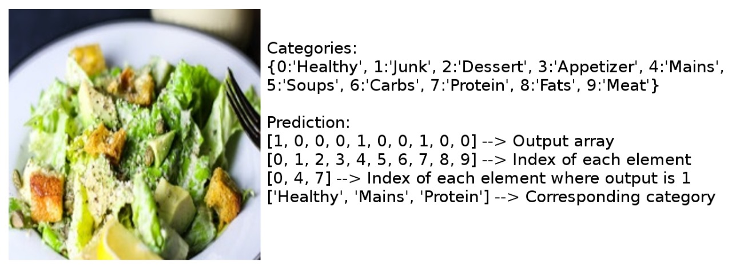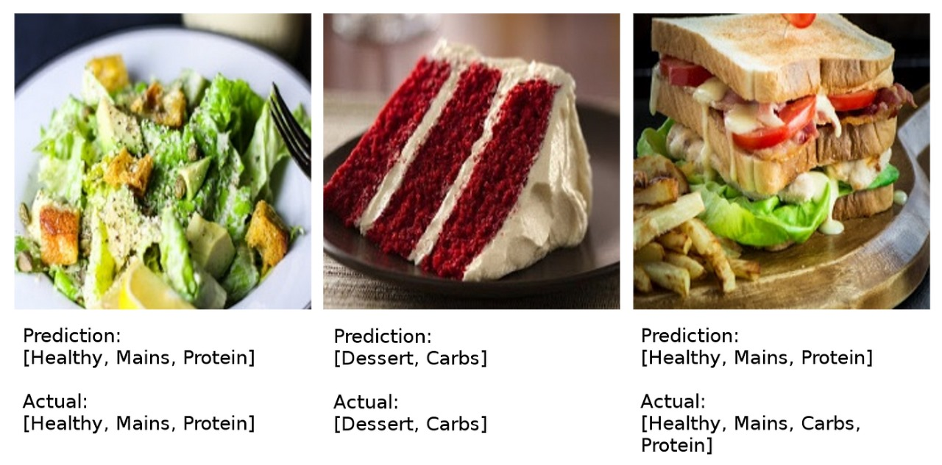

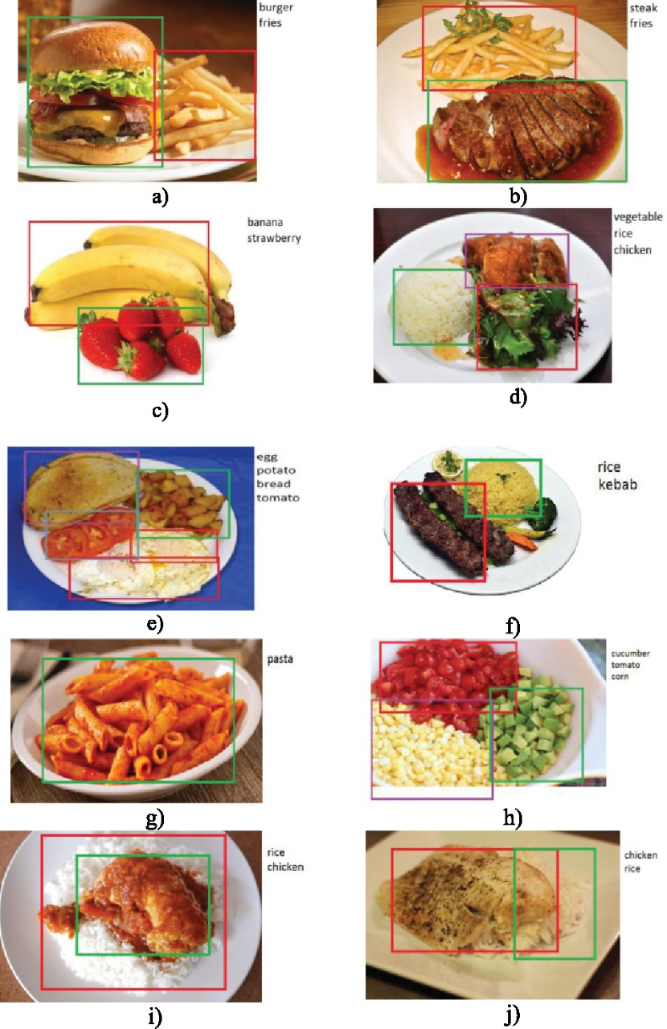

CHAPTER 6

CONCLUSION

This mainly focus on how deep learning techniques can be used for food object recognition. It has been surveyed a wide range of articles designed for automated food image recognition. The paper covers Popular networks for deep learning, mostly used frameworks, famous service available for object detection and Standards datasets. Different segmentation and classification techniques have also been studied. According to the authors Knowledge, this is the first article that has fully focused on the food object recognition through deep learning and studies every phase of food object recognition. Also, it has been cleared from the challenges and the studies that there is no such model exists that can recognize each and every type of food, Every model has its own limitations due to the nonlinear nature food. It has been concluded that food image recognitions a hot topic in computer vision and the use of convolution neural network has been improved the result accuracy of food image recognition. It has been observed that there are variety of food domain that has not been touched yet, as not much work done on recognition of liquid food items, also there is very less work done till now for Indian cuisine. In fact, there are very limited number of dataset exit for Indian Food so in future more work in the area need to be focused. The result achieved by deep learning for recognition of food images will attract more researcher to put efforts in the field of food domain through deep learning in the future.

CHAPTER-7

REFERENCE

[1] Tallapragada, V.S., Kumar, G.P., Reddy, D.V. and Narasihimhaprasad, K.L., 2021. Image Denoising Using Low Rank Matrix Approximation in Singular Value Decomposition. REVISTA GEINTEC-GESTAO INOVACAO E TECNOLOGIAS, 11(2), pp.1430-1446
[2] D.Venkat Reddy, V. V. Satyanarayana Tallapragada*, K. Raghu, M. Venkat Naresh. (2020). Hybrid Tone Mapping with Structural and Edge-preserving Priors. International Journal of Advanced Science and Technology, 29(7), 5135- 5143. Retrieved from http://sersc.org/journals/index.php/IJAST/article/view/ 23592
[3] Tallapragada, V.V., Manga, N.A., Kumar, G.V. and Naresh, M.V., 2020. Mixed image denoising using weighted coding and non-local similarity. SN Applied Sciences, 2(6), pp.1-11.
[4] Satyanarayana Tallapragada VV, Potlabathini R, Naramada A (2019)Rain Streak removal using sparse coding.Int J Sci Technol Res8:1828-1833
[5] Tallapragada, V.V., Alivelu Manga, N., Nagabhushanam, M. V. and Venkatanaresh, M., 2022.Greek Handwritten Character Recognition Using Inception V3. In Smart Systems: Innovations in Computing (pp.247-257). Springer, Singapore.
[6] Satyanarayana Tallapragada, V.V., Bhaskar Reddy, B., Ramamurthy, V. and Sunkara, J.K., 2020. Effective Comprression of Dgitial Images Using SPIHT Coding with Selective Decomposition Bands. In Advances in Electrical and Computer Technologies(pp. 955-961). Springer, Singapore.
[7] Tallapragada, V.V., Kullayamma, I., Kumar, G.V. and Venkatanaresh, M., 2022. Significance of Interenet of Things (IOT) in Health Care with Trending Smart Application, In Smart Systems: Innovations in Computing (pp. 237-247). Springer, Singapore.
[8] Zhou, L., Zhang, C., Liu, F., Qiu, Z., & He, Y. “Application of Deep Learning in Food: A Review.” Comprehensive Reviews in Food Science And Food Safety, Vol. 18, pp. 1793-1811, 2019.
[9] Farinella, G.M., Moltisanti, M., &Battiato, S., “Classifying food images represented as Bag of Textons.” IEEE International conference on image Processing (ICIP), Paris, pp. 5212-5216, doi: 10.1109/ICIP.2014.7026055,2014.

